Installation in Fibaro Home Center 2 - Update: 4.580
Step by step guide on how to include and setup the Heatit Z-TRM3 thermostat in Home Center 2.
This is guide is made for Home Center 2 FW4.580 and parts may change with different firmware versions. Please check you firmware before following steps.
Assumptions:
- The guide assumes the user has basic knowledge of the system.
- The guide assumes the user has Heatit Z-TRM3 (5430599)
- The guide assumes the user uses firmware version 4.580 on Fibaro Home Center 2.

Regular inclusion of the thermostat
Please follow the manual adding procedure described in manual of Heatit Z-TRM3.
Add the device in Home Center 2.
Settings
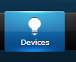
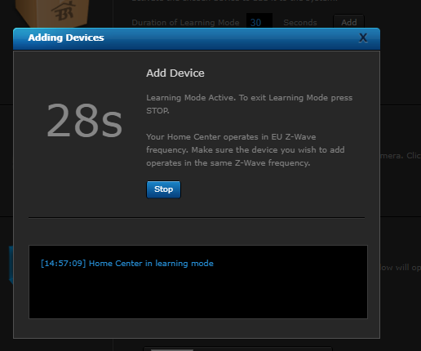
Adding can now be started from thermostat as well.
Choose «Z-Wave Device»
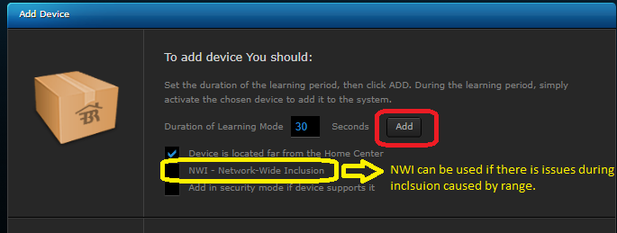
Enter Devices page
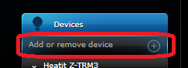

Remove devices not needed to be shown in system
Devices circled in red is not used and should be hidden in the system to avoid confusion.
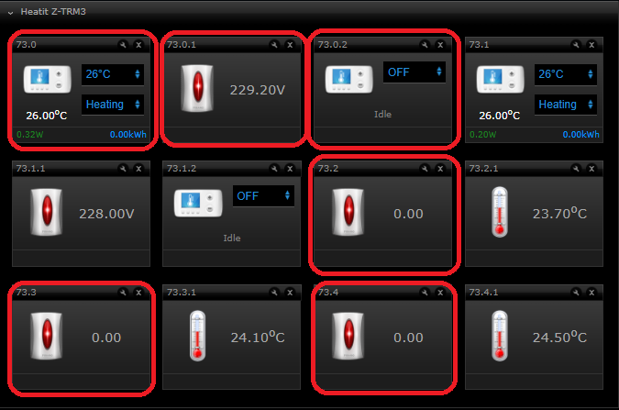
Device description:
Hidden (X) | Device name in system (default) | Device description | Suggested name
X | 73.0 | Single Channel Thermostat Setpoint
X | 73.0.1 | Single channel voltage device
X | 73.0.2 | Single Channel Thermostat mode
 | 73.1 | Multichannel Channel Thermostat Setpoint | Thermostat Setpoint
 | 73.1.1 | Multichannel Channel voltage device | Voltage
 | 73.1.2 | Multichannel Channel Thermostat Mode | Thermostat Mode
X | 73.2 | Device used for communication with gateway
 | 73.2.1 | Sensor value reported from internal sensor | Room Temperature
X | 73.3 | Device used for communication with gateway
 | 73.3.1 | Sensor value reported from external sensor | External Temperature
x | 73.4 | Device used for communication with gateway
 | 73.4.1 | Sensor value reported from floor sensor | Floor Temperature
How to hide a device:
Repeat the procedure for all device need circled in red on previous page.
Cross off for device is hidden in the system.
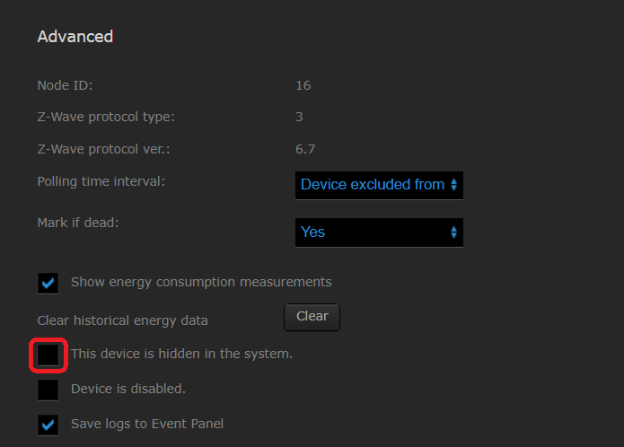
Press disc icon to save changes
Press wrench symbol when hovering any of the devices
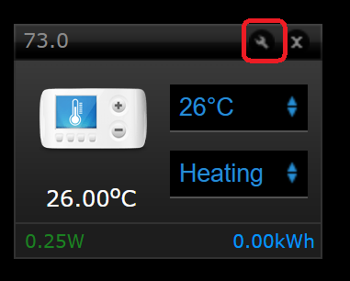
Enter Advanced configuration
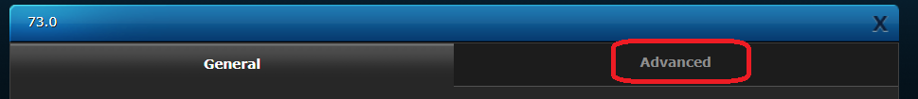

Remove incorrect associations
Wait for associations to be removed (between 30 and 90 seconds based on range)
Use endpoint 0 – group 1
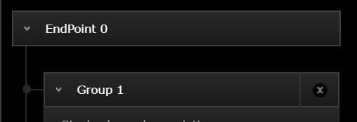
Remove cross for single and multichannel
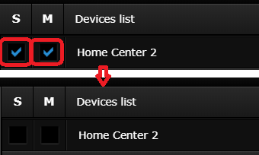
Save changes (found at bottom of pop-up screen)

When in advanced configuration page, go to setting associations
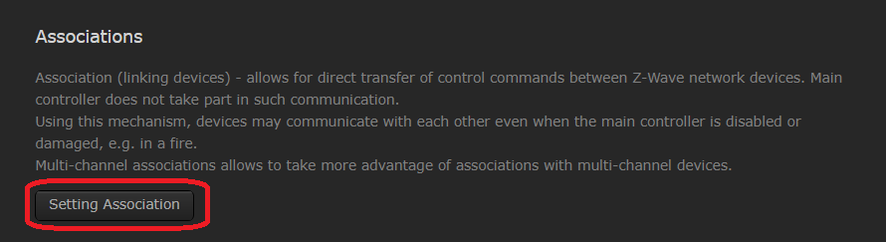

Set associations to enable correct messaging
Wait for associations to be added (between 30 and 90 seconds based on range)
The thermostat is now setup properly
Now, enter setting associations and add correct associations as shown:
Enter «Endpoint 0» «Group 1»
Use multichannel associations
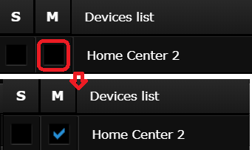
Save changes (found at bottom of pop-up screen)

When in advanced configuration page, go to setting associations

