Installation in fibaro Home Center 2 - Update: 4.580
Step by step guide on how to link Heatit Z-TRM3 to Heatit Z-Water or other external relay.
This is guide is made for Home Center 2 FW4.580 and parts may change with different firmware versions. Please check you firmware before following steps.
Assumptions:
- The guide assumes the user has basic knowledge of the system.
- The guide assumes the user has Heatit Z-TRM3 (5430599)
- The guide assumes the user uses firmware version 4.580 on Fibaro Home Center 2.
- The guide assumes the thermostat is already correctly setup in the gateway.

Device list
Devices circled in red is used not used and should be hidden in the system to avoid confusion.
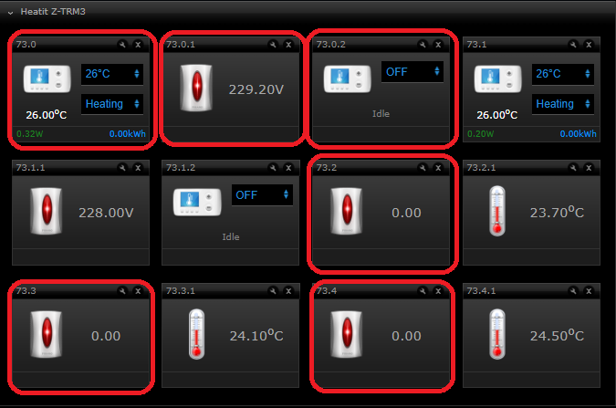
Device description:
Hidden (X) | Device name in system (default) | Device description | Suggested name
X | 73.0 | Single Channel Thermostat Setpoint
X | 73.0.1 | Single channel voltage device
X | 73.0.2 | Single Channel Thermostat mode
 | 73.1 | Multichannel Channel Thermostat Setpoint | Thermostat Setpoint
 | 73.1.1 | Multichannel Channel voltage device | Voltage
 | 73.1.2 | Multichannel Channel Thermostat Mode | Thermostat Mode
X | 73.2 | Device used for communication with gateway
 | 73.2.1 | Sensor value reported from internal sensor | Room Temperature
X | 73.3 | Device used for communication with gateway
 | 73.3.1 | Sensor value reported from external sensor | External Temperature
x | 73.4 | Device used for communication with gateway
 | 73.4.1 | Sensor value reported from floor sensor | Floor Temperature

Setup assocations from the Heatit Z-TRM3 to external relay.
Enter configuration of device either of the following devices:
“73.1”
“73.1.1”
“73.1.2”
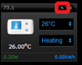
Enter Advanced configuration

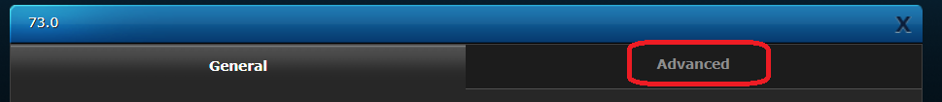
When in advanced configuration page, go to setting associations
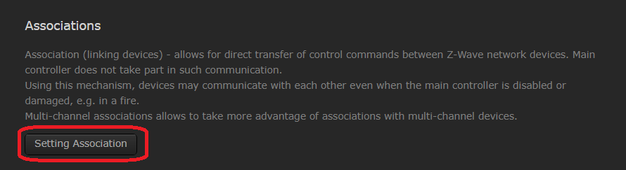

Use endpoint 1 – group 2 as described in manual.
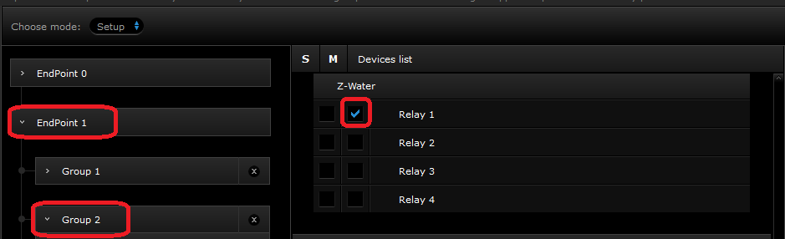
Here we are setting the configuration in “M” for multichannel mode, this is device specific for Heatit Z-Water and may not work for all devices. If it does not work, please cross off under “S” for single channel instead
Save changes (found at bottom of pop-up screen)
Wait for associations to be added (between 30 and 90 seconds based on range)
The thermostat is now controlling the external relay.

