1. Download Zensys Tools here: https://assistance.domadoo.com/article/zensys-tool-2555.html
​2. Close Software that is linked to Z-Stick Gen5
3. Unzip Zensys Tools file, and open the .exe file.
4. Click and highlight your Doorbell 6 (in our image, it is Node #3)
5. Select "Node Info" button (4th button on the left)
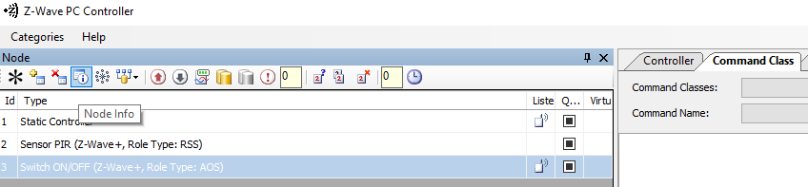

6. Now open up "Command Class" tab on the right side of the software
7. Select:
Command Classes: "COMMAND_CLASS_MULTI_CHANNEL_V2"
Command Name: "MULTI_CHANNEL_CMD_ENCAP"
​
8. Input these Values:

Source End Point: 00 // leave as default
Res: 00 //Don't touch this, this does nothing.
Destination Endpoint: 02 // Tamper Switch endpoint of Siren or Doorbell 6, you can use this to control sound of your button or other alarm options
Bit address: 00
Command Class: 79 //Sound Switch Command Class
Command: 05 //Sound Switch Configuration Set Command
Parameter: 05 01 //Volume #5 (as 05) Sounds #01 (as 01)
- Volume is a range between 00 - 65 (in hex which is 0 - 100 in decimal or easily seen as 0 - 100%)
- Sound can be a range between 00 - 1E (or decimal value of 1 - 30 or sound #1 - 30).
  - Example, Sound = 05, Volume = 0A (10%)
    - Parameter: 0A 05
